Experiment - 3.1

1. **AIM:**

Implement building blocks for Android Application using different layouts (such as linear, relative and absolute).

# CODE:

## MainActivity.java

package com.example.myapplication9; import android.content.Intent; import android.os.Bundle; import android.widget.Button;

import androidx.appcompat.app.AppCompatActivity; public class MainActivity extends AppCompatActivity {

@Override

protected void onCreate(Bundle savedInstanceState) { super.onCreate(savedInstanceState); setContentView(R.layout.*activity_main*);

Button linearLayoutButton = findViewById(R.id.*linear_layout_button*); Button relativeLayoutButton =

findViewById(R.id.*relative_layout_button*);

Button absoluteLayoutButton = findViewById(R.id.*absolute_layout_button*); linearLayoutButton.setOnClickListener(v -> {

Intent intent = new Intent(MainActivity.this, LinearLayoutActivity.class);

startActivity(intent);

});

relativeLayoutButton.setOnClickListener(v -> {

Intent intent = new Intent(MainActivity.this, RelativeLayoutActivity.class);

startActivity(intent);

});

absoluteLayoutButton.setOnClickListener(v -> {

Intent intent = new Intent(MainActivity.this, AbsoluteLayoutActivity.class); startActivity(intent);

});

}

}

## activity_main.xml

<LinearLayout

xmlns:android[="http://schemas.android.com/apk/res/android"](http://schemas.android.com/apk/res/android) android:orientation="vertical" android:layout_width="match_parent" android:layout_height="match_parent">

<Button android:text="@string/linear_layout" android:layout_width="wrap_content" android:layout_height="wrap_content" android:id="@+id/linear_layout_button" android:textSize="18sp" android:layout_marginTop="40dp" android:layout_gravity="center_horizontal "/>

<Button android:text="@string/relative_layout" android:layout_width="wrap_content" android:layout_height="wrap_content" android:id="@+id/relative_layout_button" android:textSize="18sp" android:layout_gravity="center_horizontal"/>

<Button android:text="@string/absolute_layout" android:layout_width="wrap_content" android:layout_height="wrap_content" android:id="@+id/absolute_layout_button" android:textSize="18sp" android:layout_gravity="center_horizontal"/>

<TextView android:id="@+id/textView" android:layout_width="match_parent" android:layout_height="wrap_content" android:textSize="16sp" android:layout_marginTop="40dp" android:layout_marginStart="10dp" android:text="@string/Simran" />

<TextView android:id="@+id/textView2" android:layout_width="match_parent" android:layout_height="wrap_content" android:textSize="16sp" android:layout_marginTop="10dp"

android:layout_marginStart="10dp" android:text="@string/20BCS3400" />

</LinearLayout>

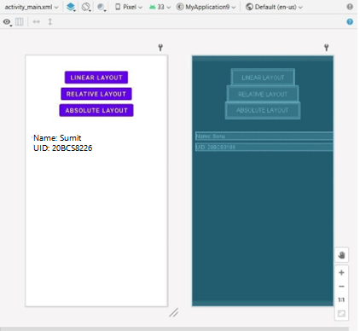

## LinearLayoutActivity.java

package com.example.myapplication9; import android.os.Bundle; import androidx.appcompat.app.AppCompatActivity; public class LinearLayoutActivity extends AppCompatActivity {

@Override

protected void onCreate(Bundle savedInstanceState) { super.onCreate(savedInstanceState); setContentView(R.layout.*activity_linear_layout*); }

}

## activity_linear_layout.xml

<LinearLayout

xmlns:android[="http://schemas.android.com/apk/res/android"](http://schemas.android.com/apk/res/android) android:orientation="vertical" android:layout_width="match_parent" android:layout_height="match_parent">

<TextView

android:text="@string/element_11" android:textSize="24sp" android:layout_width="wrap_content" android:layout_height="wrap_content"

/>

<EditText

android:hint="@string/element_22" android:textSize="24sp" android:layout_width="match_parent" android:layout_height="wrap_content"

/>

<Button

android:layout_width="wrap_content" android:layout_height="wrap_content" android:textSize="24sp" android:text="@string/element_33" />

</LinearLayout>

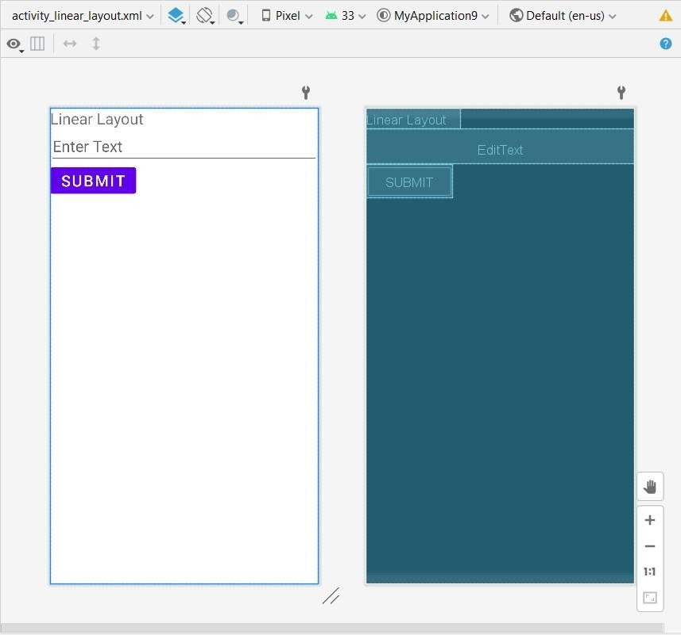

## RelativeLayoutActivity.java

package com.example.myapplication9; import android.os.Bundle; import androidx.appcompat.app.AppCompatActivity; public class RelativeLayoutActivity extends AppCompatActivity {

@Override

protected void onCreate(Bundle savedInstanceState) { super.onCreate(savedInstanceState); setContentView(R.layout.*activity_relative_layout*

);

}

}

## activity_relative_layout.xml

<RelativeLayout xmlns:android[="http://schemas.android.com/apk/res/android"](http://schemas.android.com/apk/res/android) android:layout_width="match_parent" android:layout_height="match_parent">

<TextView

android:text="@string/element_1" android:textSize="24sp" android:layout_width="wrap_content" android:layout_height="wrap_content" android:id="@+id/text_view_1" android:layout_alignParentTop="true" android:layout_alignParentStart="true " android:layout_marginStart="16dp" android:layout_marginTop="16dp"/>

<EditText android:hint="@string/element_2" android:textSize="24sp" android:layout_width="match_parent" android:layout_height="wrap_content" android:id="@+id/edit_text_1" android:layout_below="@id/text_view_1" android:layout_alignStart="@id/text_view

_1" android:layout_marginTop="16dp"/>

<Button android:text="@string/element_3" android:textSize="24sp" android:layout_width="wrap_content" android:layout_height="wrap_content" android:id="@+id/button_1" android:layout_below="@id/edit_text_1" android:layout_alignStart="@id/edit_text

_1" android:layout_marginTop="16dp"/>

</RelativeLayout>

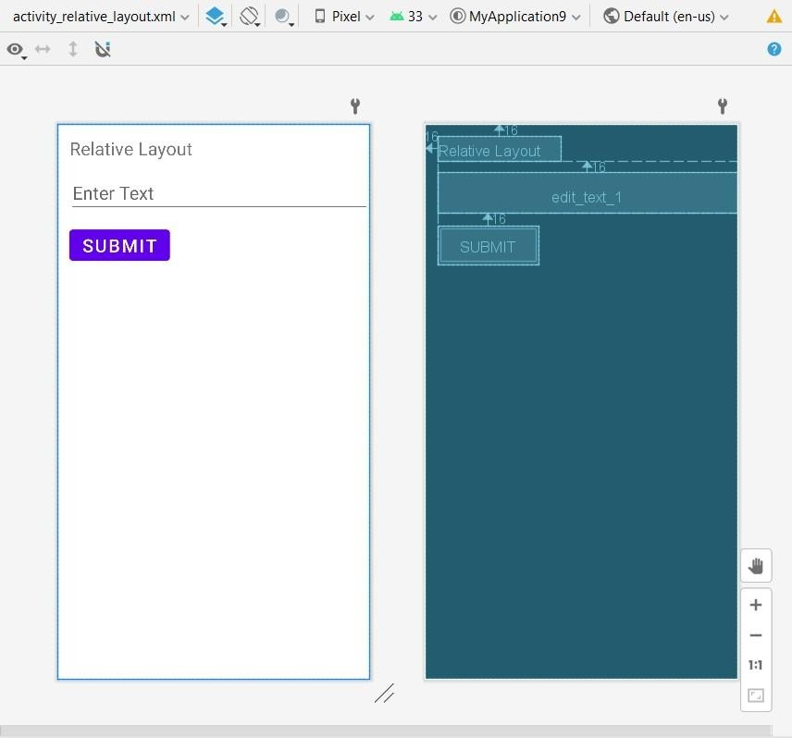

## AbsoluteLayoutActivity.java

package com.example.myapplication9; import android.os.Bundle; import androidx.appcompat.app.AppCompatActivity; public class AbsoluteLayoutActivity extends AppCompatActivity {

@Override

protected void onCreate(Bundle savedInstanceState) { super.onCreate(savedInstanceState); setContentView(R.layout.*activity_absolute_layout*)

; }

}

## activity_absolute_layout.xml

*<?*xml version="1.0" encoding="utf-8"*?>*

<AbsoluteLayout xmlns:android[="http://schemas.android.com/apk/res/android"](http://schemas.android.com/apk/res/android) android:layout_width="match_parent"

android:layout_height="match_parent">

<TextView

android:text="@string/element_111" android:layout_width="wrap_content" android:layout_height="wrap_content" android:id="@+id/text_view_1" android:textSize="24sp" android:layout_x="100dp" android:layout_y="100dp"/>



<EditText

android:hint="@string/element_222" android:textSize="24sp" android:layout_width="150dp" android:layout_height="wrap_content" android:id="@+id/edit_text_1" android:layout_x="50dp" android:layout_y="200dp"/>

<Button

android:text="@string/element_333" android:textSize="24sp" android:layout_width="wrap_content" android:layout_height="wrap_content" android:id="@+id/button_1" android:layout_x="200dp" android:layout_y="300dp"/>

</AbsoluteLayout>

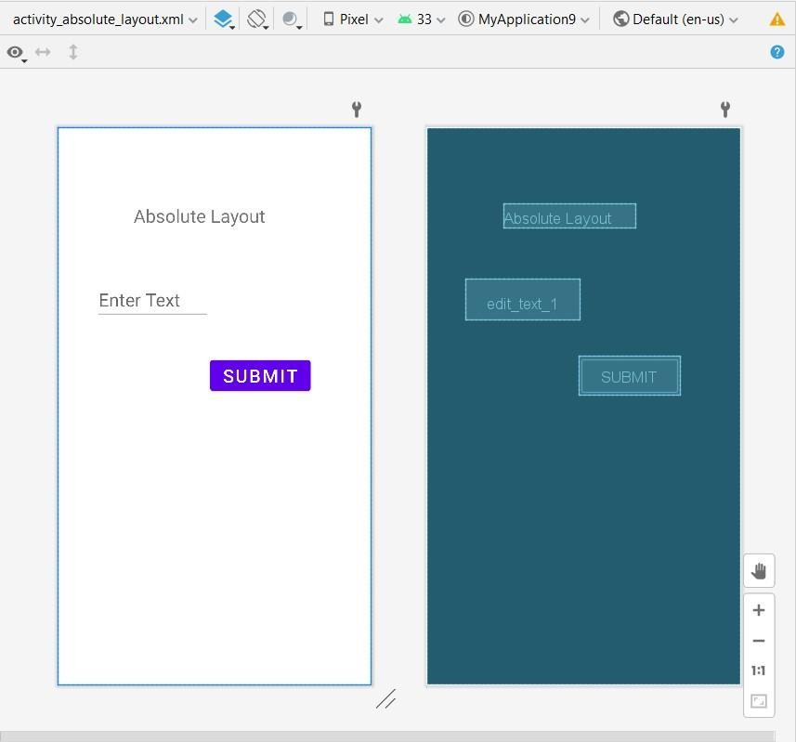

1. **OUTPUT:**

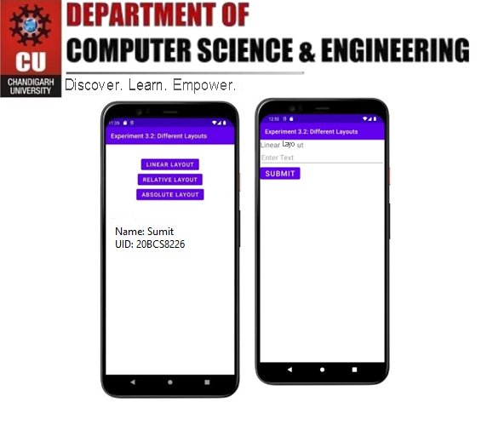

**Output for Linear Layout**

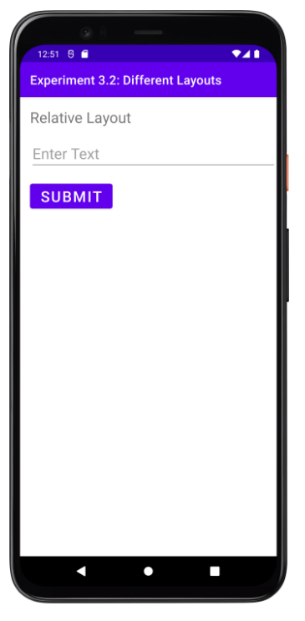 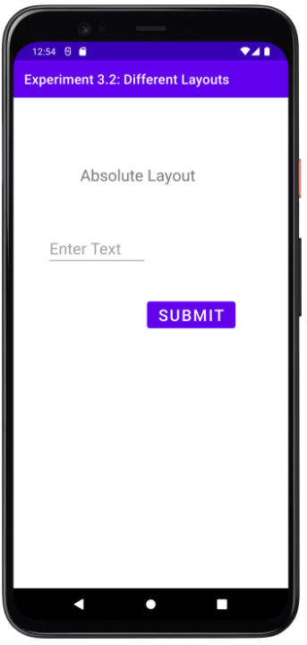

**Output for Relative Layout Output for Absolute Layout**